**Onepager and Stock increase Run by Jupyter Lab**  
  
Step 1 – Win+R open pop up  
 Step 2 - write cmd  
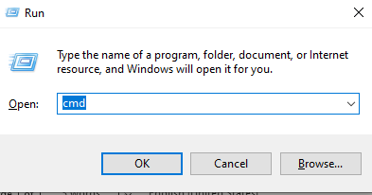

Step - 3

Open Terminal  
write – Jupyter lab  
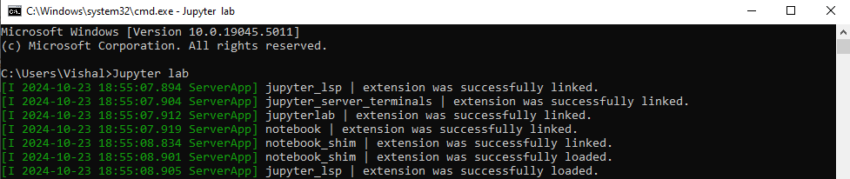  
step 4

Auto open Current browser   
run script   
Shift + Enter  
 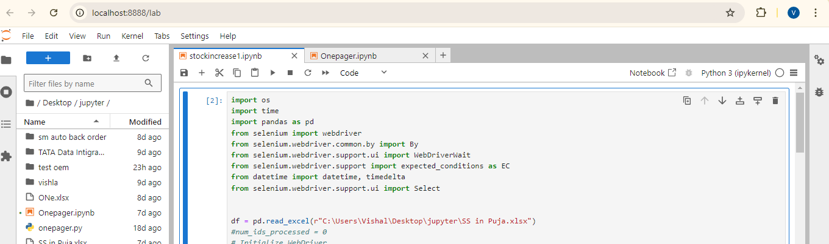

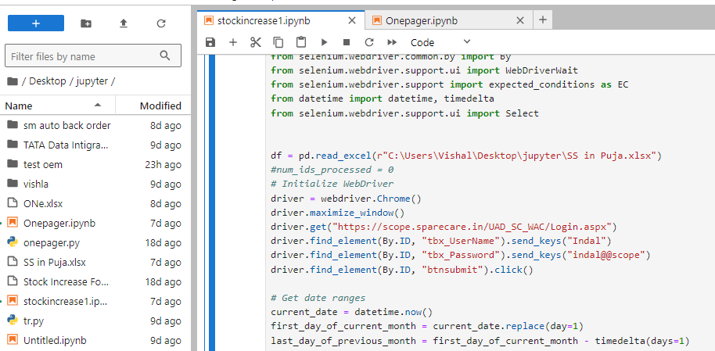change file path if change file source